Solidarity Award

IQBAL MASIH

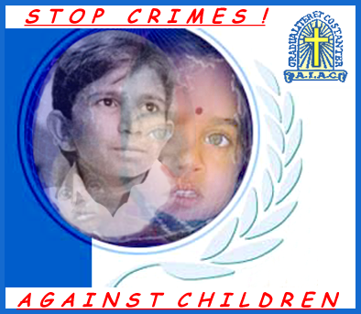
A courageous child
An images to identify
the production obtained without any use
of children's works
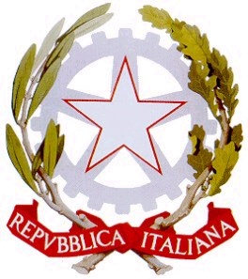
Patrocinio del
Senato della Repubblica

Parlamento Europeo - Ufficio per l'Italia

Rappresentanza in Italia della Commissione europea
Regione Campania
Provincia di Napoli

Comune di Napoli


Provveditorato agli studi di Napoli
Comitato Italiano

International Solidarity Award
2nd Edition

“IQBAL MASIH”
A courageous child

for the

NOBEL PRIZE

The International Association Catholic Apostolate

has deemed extremely important to promote and an

ETHIC COMMISSION

SOCIAL-ECONOMIC-POLITICAL-SCIENTIFICAL
PHILOSOPHICAL-RELIGIOUS

Humanity who does not respeet children is without a future.

A signature to be different in logic and freedom of thought

IQBAL MASIH giving us as a gift his young life knew and chose
to die in order to question us all, without distinetions, and in order to
oblige us to refleet trying to understand and feel the need to repair in
time to the absurd and vile abuse and use of childhood.

CHILDREN HAVE ALWAYS BEEN LOOKING AT US.

Presentation of the new logo

“Stop Crimes ! Against Children”
(copyright by “Esistenza” – Italy)

An image to identify productions which
do not involve children’s work

Presentation Programme

23rd April 2001

ROMA

FEDERAZIONE NAZIONALE STAMPA ITALIANA
Corso Vittorio Emanuele, 349-Roma-Tel.06/683.38.79

